**Ideation Phase**

**Brainstorm & Idea Prioritization Template**

|  |  |
| --- | --- |
| Date | 26-6- 2025 |
| Team ID | LTVIP2025TMID59482 |
| Project Name | ALPHA Works – FreelanceFinder |
| Maximum Marks | 4 Marks |

**Brainstorm & Idea Prioritization Template:**

ALPHA Works – FreelanceFinder is an innovative freelancing platform designed to seamlessly connect clients with skilled freelancers across various domains. It focuses on streamlining the freelance hiring process through an intuitive interface, real-time communication tools, and secure project management workflows.

This brainstorming session template fosters a free and collaborative space where all team members are encouraged to contribute unique, creative, and out-of-the-box ideas. The goal is to identify, group, and prioritize key features that enhance platform usability, reliability, and overall experience for both freelancers and clients.

Use this document to capture your team’s imagination and transform raw ideas into structured, prioritized solutions that align with the mission of ALPHA Works—empowering freelancers and unlocking potential for all users involved.

**Step-1: Team Gathering, Collaboration and Select the Problem Statement**

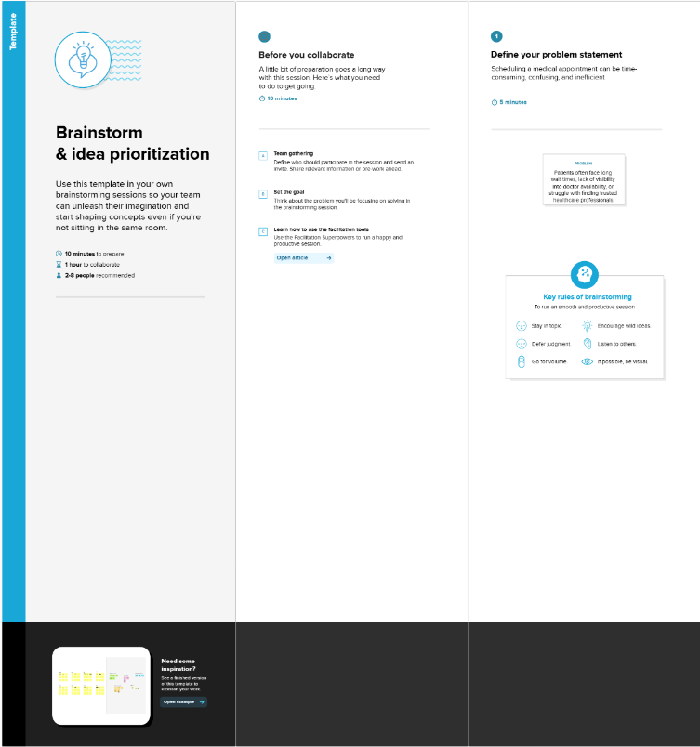

**Step-2: Brainstorm, Idea Listing and Grouping**

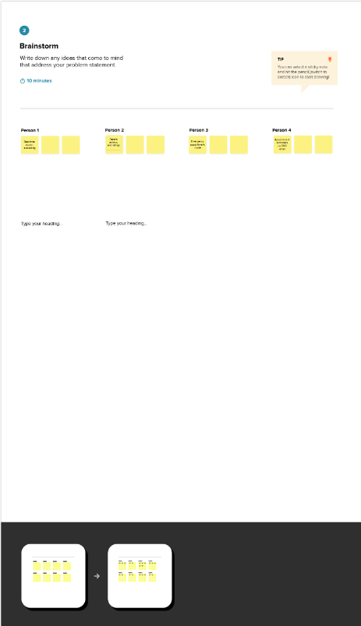

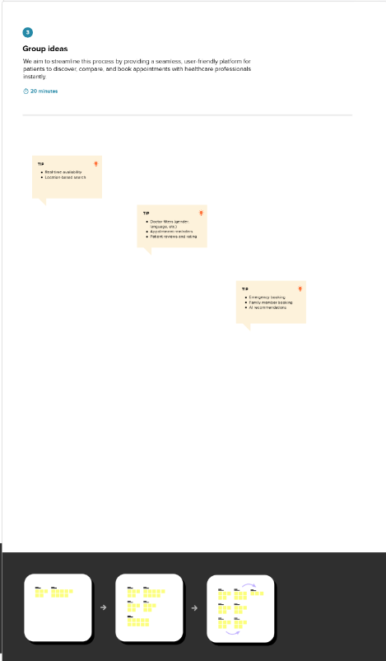

**Step-3: Idea Prioritization**

